**Base Finger Design Modifications**

A fully functional base finger design was completed by the end of phase 3. However, since then, several modifications were added to the design in order to make the finger even easier to print and cable. The changes included redesigned and repositioned wire guides, conical joint pins, reduced height, and smaller tolerances.

The wire guides were redesigned because although the previous design functioned well, it featured relatively large overhangs where the current wire guides, round pins, bridged across the center of the finger. The new design has fewer guides (since some of the existing guides turned out to be unnecessary), and the guides are now flat faces with a hole for wire. This design eliminates overhangs, since the hole is round and therefore graduates up to the bridge in the center. The guides were also made thinner and moved downward, which increased the finger’s range of motion (since before there was a small amount of friction within the joints).

The joint pins were changed from a cylindrical to a conical design for the same reasons as the change in cable guides. By starting the pins large and tapering them to become smaller, the printer goes from making a large overhang in one pass, which is very prone to drooping down and bridging to the joint hole, to making a lot of small overhangs, each stacked on top of the other, in a graduation. This is far less prone to bridging, and, as long as the angle is kept under 45 degrees will actually not deform in a standard hobbyist 3D printer.

Height of the fingers was also reduced by 4mm to make them slightly less blocky and more realistic. Previously they had been a little too tall and blocky. Finally, the tolerances between joints were significantly lowered. This was because the joints in the previous base finger were fairly loose and one of the TAs suggested lowering the tolerance to a standard accepted level for printed revolute joints (.02 inches) to decrease this looseness.

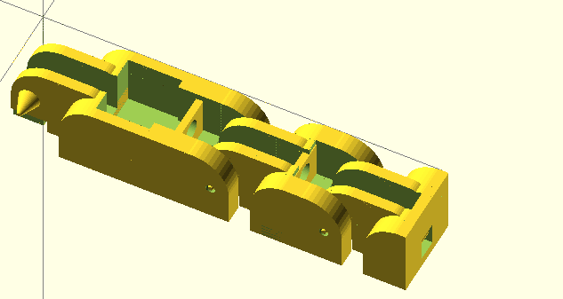

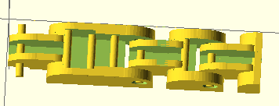

**Palm Design Modifications**

Figure xxx: Previous finger iteration (left) with pin-shaped cable guides, round joint pins, and large tolerances, and new finger iteration (right) with redesigned cable guides, conical pins, and lower tolerance.

At the end of Phase 3, a palm design had been completed with 4 low-level cable guides running along the palm, toward the wrist. This palm design also had no guard keeping the granular jamming pad from interfering with the thumb, no mounting point for the forearm, and was rather thick.

The palm was therefore heavily modified prior to Phase 4 with taller and more complete cable guides, a mounting point for the forearm, a guard for the thumb, and thinner sides. The fingers were also moved further apart, to prevent bridging, and the thumb was moved away from the side of the palm for the same reason.

These new, taller, cable guides were very important since the original cable guides were very low to the palm surface. Forcing the cables downward actually decreases their leverage on the fingers, taking more energy to curl the hand inward—or worse, possibly creating a toggle point and stopping motion before the finger is fully bent. OpenSCAD does not support a sweep or loft feature, so small gaps were left in between these cable guides where their direction was changed. This is however not an issue because the granular jamming pad is not so fluid that it will fill in these small gaps.

The forearm mounting point just consisted of a flat plate with holes for four plastic screws. The holes are slightly larger than screw diameter, making it possible to drop them through the palm wrist attachment and thread into the forearm, ensuring a tight fit with no gaps.

The thumb guard exists so that the granular jamming pad cannot spill over the side of the palm and create friction against the side of the thumb. This ensures a good range of motion for the thumb and prevents unnecessary wear on the granular jamming pad.

Finally, the fingers and thumb were spaced out more to prevent the plastic from bridging between fingers or between thumb and palm and impeding motion. The final palm design was as follows:

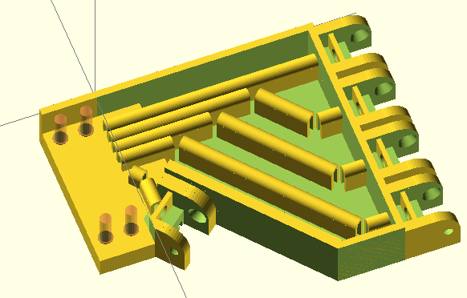 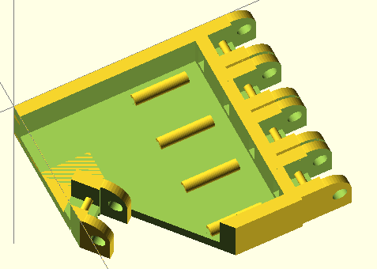

Figure xxx: Previous palm iteration (left) with low level cable guides, no forearm mount, and no thumb guard. Current palm iteration (right) with and more complete cable guides, a forearm mount, and a thumb guard.

**Overall Hand Design Modifications**

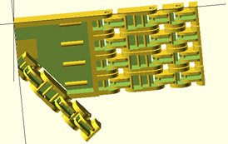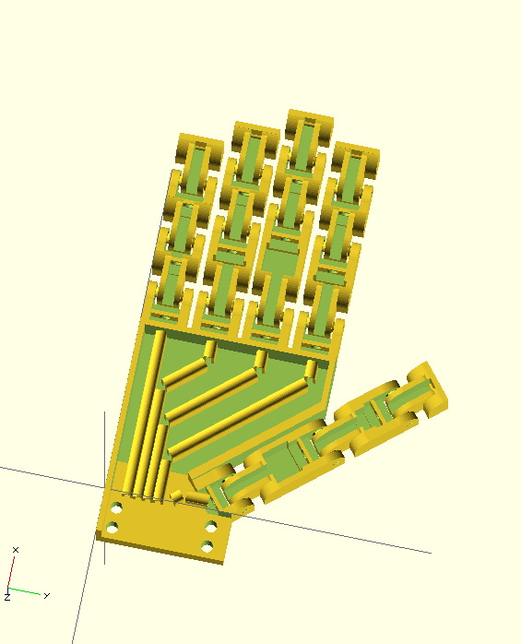At the conclusion of Phase 3 a hand design had been completed with all equally sized fingers. For Phase 4, finger length was adjusted to match the proportions of real, human fingers. Every finger (with the exception of the pinky) is exactly the length of the average human equivalent. The pinky is about 10cm longer than average due to the hinge design—any shorter and the hinges would overlap and the finger would be unable to bend.

Figure xxx: Previous (left) and current (right) hand iterations. Current hand iteration includes updated palm, updated base finger design, and realistic finger lengths.

**Prototype Fabrication Plan and Cost**

The first complete hand prototype was printed on Thursday, February 6th. All of the 3D printed parts will be produced using the 3D printing facilities at Carnegie lab. The majority of the non-printable parts have already been ordered. Cost thus far has been does Sean know how much we’ve spent so far?, well within budget, with the ordered parts coming at their budget, and the hand itself using 150 cm3 of ABS plastic, costing about $7.05 in material.

Future plans for fabrication include slightly modifying the hand design and printing the final iteration (which should occur within the next 1-2 weeks), then finalizing and printing the forearm design (scheduled for completion within about a month) and then finally assembling the parts and writing some basic programs for grips, etc.

The granular jamming pad has been designed and production of the pad will begin within the next 1-2 weeks. The current plan for granular jamming pad production is to 3D print a mold out of ABS and then use it to slip-cast silicone. Now that the pad design is complete it should be trivial to use it to make two mold halves and an inner mold surface.

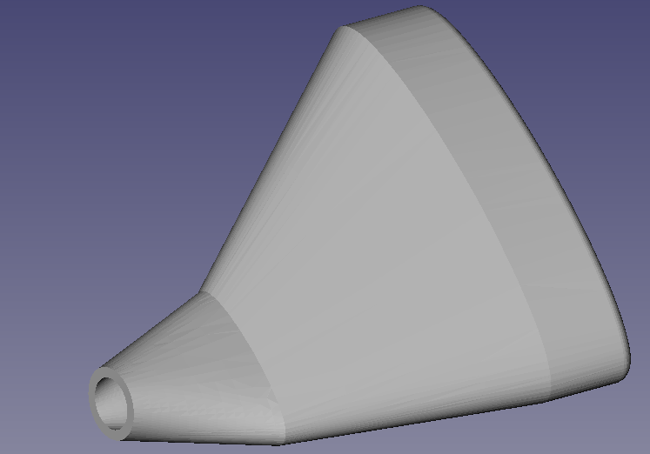

**Performance Testing**

Figure xxx: Granular jamming pad design.

The first iteration of the complete hand was a moderate success. Most parts of the hand worked successfully, though some aspects need to be modified in the future.

The redesigned fingers were all individually successful. The new cable guides increased range of motion, printed successfully, and worked exactly as expected, such that pulling on the cable produced full motion of the digit. The base knuckle, the joint between the finger and palm, also worked successfully. This is notable because prior to manufacture of the hand as a whole, the base joint had never been tested (only the top two joints were tested, with the base hinge printed without its mate). Additionally, all the fingers worked at all their different respective lengths. This is another element of the project that had not yet been tested, and has proven successful. The hand is also proportionate to a real, human hand.

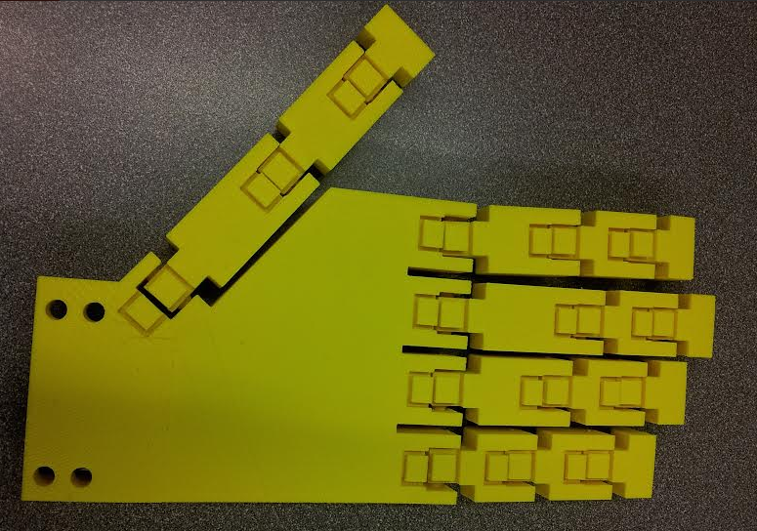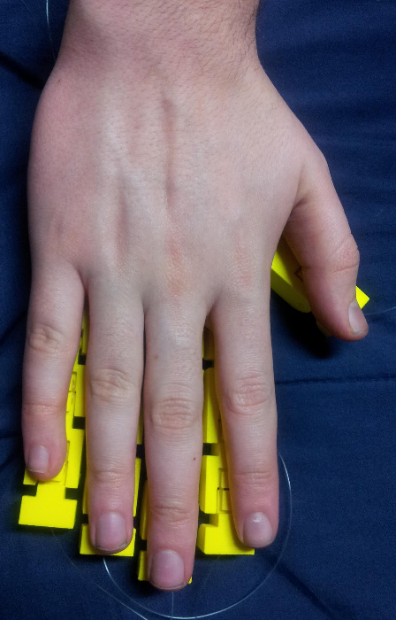

Figure xxx: Hand model compared to a human hand.

The only major problem with the fingers was that the tolerance suggested by the TA was actually slightly too small, and the sides of the hinge interior bridged to the inside of the exterior portion of the hinge. The same tolerance was also used for the revolute portions of the joints (between the joint pins and their housings), where it worked very well and completely eliminated rattling, as well as removing the necessity for bearings. The bridging between hinges was fairly easy to break via forcing the fingers through their range of motion, however there is a great deal of internal friction in the joints still, and looking inside them reveals some jagged, broken off webbing between the joint sections. Due to this friction, it also takes more tension than necessary to pull in the fingers. The solution to this is simply to slightly raise the tolerance for the next print iteration. Despite the fact that it had been set to an accepted value, 3D printing is very prone to changes in humidity, etc, and this larger tolerance will be used in the future.

The palm printed correctly except for one fairly large error. The cable guides for the palm actually hover above the palm surface, meaning that those cable guides not directly attached to palm walls actually broke off. Some inspection showed that this was a problem with the original model, however, and that it hadn’t been noticed because the gap was blocked by other features in OpenSCAD views. This problem has been immediately rectified for future designs. Printing the palm also made it clear that the wire guides only needed to be about half their original height, which is good news because it means that they can be made shorter in the next iteration, making more room for the granular jamming pad (allowing it to be “deeper” means that it will have greatly increased gripping ability). Aside from these two minor problems, however, the palm is complete.

The hand design does have one major issue, however. With the current orientation of the thumb, motion is actually almost exactly opposite to motion of a real, human thumb. This means that the angle of thumb attachment must be revisited (attaching it at the opposite angle would ensure realistic range of motion, but look very unlike a human hand when resting), and possibly a minor redesign must be performed for the thumb prior to Phase 5. However, this is the only major problem with the hand design, meaning that design is nearly complete and the bulk of focus can now be shifted to the forearm and granular jamming components.

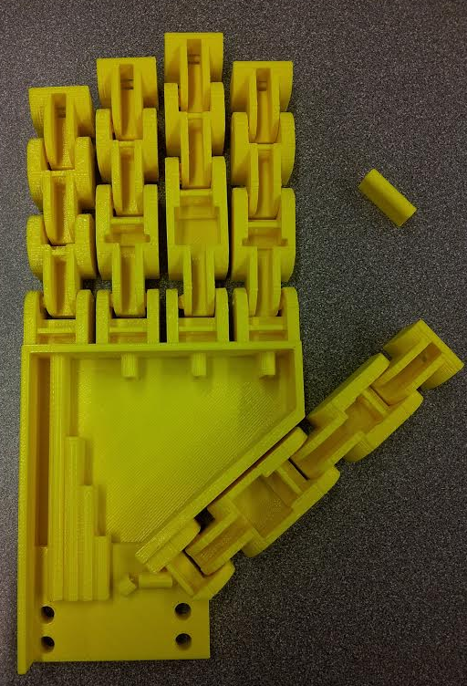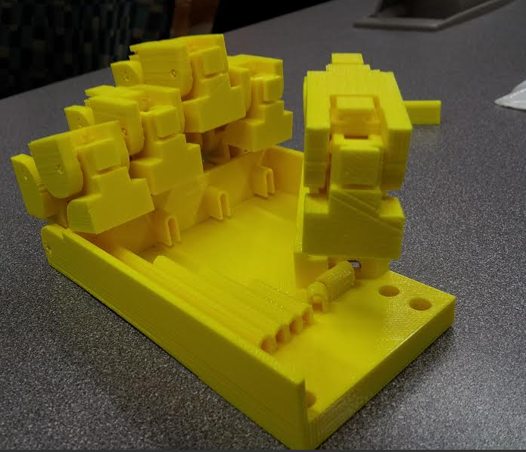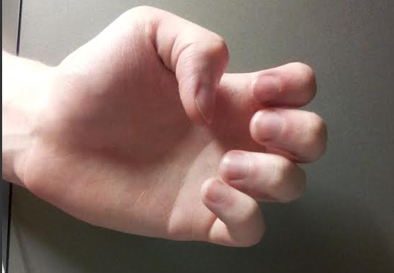

Figure xxx: Printed hand (left), printed hand displaying range of motion (middle), and actual hand displaying range of motion (right). Notice the missing joint guides, and the recovered joint guide to the top right of the first photo. Note also how the finger motion is correct, but the thumb on the printed hand bends downward, toward the wrist, while the human hand bends upward, toward the fingers.

* **Note: Make sure there is an abstract!**